SIMATS ENGINEERING
ASSESSMENT TOOL 2 - Medium(Assignment 1)
COURSE CODE: CSA09 COURSE NAME: Programming in Java COURSE OUTCOME COVERED
CO2: Implement Collection Framework interfaces such as List, ArrayList, Set, Map, HashTable, and HashMap using iterators and generics to store, retrieve, and process groups of objects in web applications.(BL3,BL4)
Assessment Tool Weightage: 10%
QUESTIONS: 40 (each student assigned distinct questions) Total Marks: 100
ANNEXURE A
Assignment 1
Code of Conduct:
I U.Roshitha certify that this submission is my original work and that I have adhered to the guidelines specified for this assessment.
I understand that any violation of academic integrity rules will result in disciplinary action.
Signature of the student:
RUBRICS FOR CALCULATION:
Criteria | Level 4 (Exemplary) | Level 3 (Proficient) | Level 2 (Developing) | Level 1 (Beginning)
Problem Understanding
Algorithm
Code Implementation
Competitive Performance
Test Case Handling

Annexure A

Assignment 1

Question 27 – Online Movie Recommendation

Problem Statement:
A streaming platform stores users' favourite movies.

Questions
- Develop a Java program using ArrayList.
import java.util.ArrayList;
import java.util.Collections;

public class MovieRecommendation {
public static void main(String[] args) {

ArrayList<String> movies = new ArrayList<>();

movies.add("Inception");
movies.add("Avatar");
movies.add("Titanic");
movies.add("Interstellar");
movies.add("The Dark Knight");

System.out.println("Favorite Movies:");
for (String movie : movies) {
System.out.println(movie);
}

Collections.sort(movies);

System.out.println("\nMovies After Alphabetical Sorting:");
for (String movie : movies) {
System.out.println(movie);
}
}
}
Implementation:
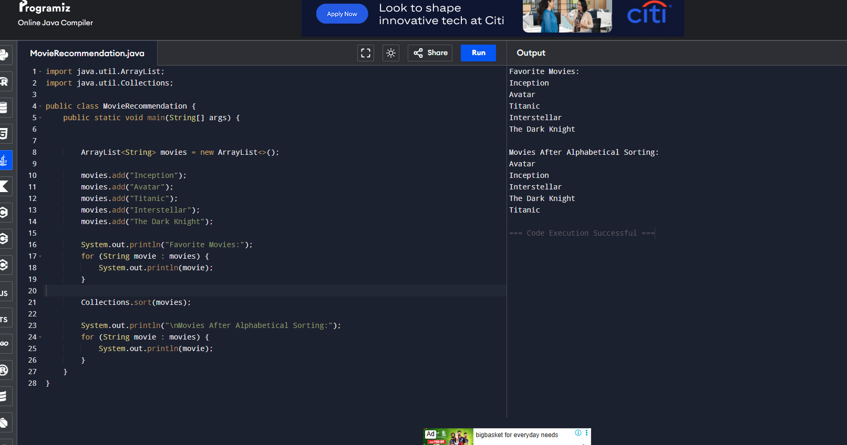
- Sort movies alphabetically.
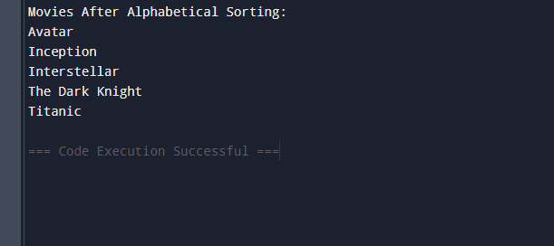

- Compare Collections.sort() and Comparator.

Collections.sort() | Comparator
Used for default (natural) sorting. | Used for custom sorting.
Sorts in ascending order by default. | Can sort in ascending, descending, or any custom order.
Simpler to use. | More flexible and powerful.
Uses the object's natural ordering (Comparable). | Requires implementing the Comparator interface.

- Explain recommendation systems.

A recommendation system is a software system that suggests movies, products, music, or other items based on a user's interests and preferences. It helps users discover content they are likely to enjoy.
Types of Recommendation Systems
- Content-Based Filtering
  - Recommends movies similar to those the user has liked before.
  - Example: If a user watches action movies, more action movies are recommended.
- Collaborative Filtering
  - Recommends movies based on the preferences of users with similar tastes.
  - Example: Users who liked Inception also liked Interstellar.
- Hybrid Recommendation
  - Combines content-based and collaborative filtering for more accurate recommendations.
Advantages
- Provides personalized recommendations.
- Saves users time in finding content.
- Improves user satisfaction.
- Increases user engagement on the platform.
- Helps streaming services recommend relevant movies efficiently.

